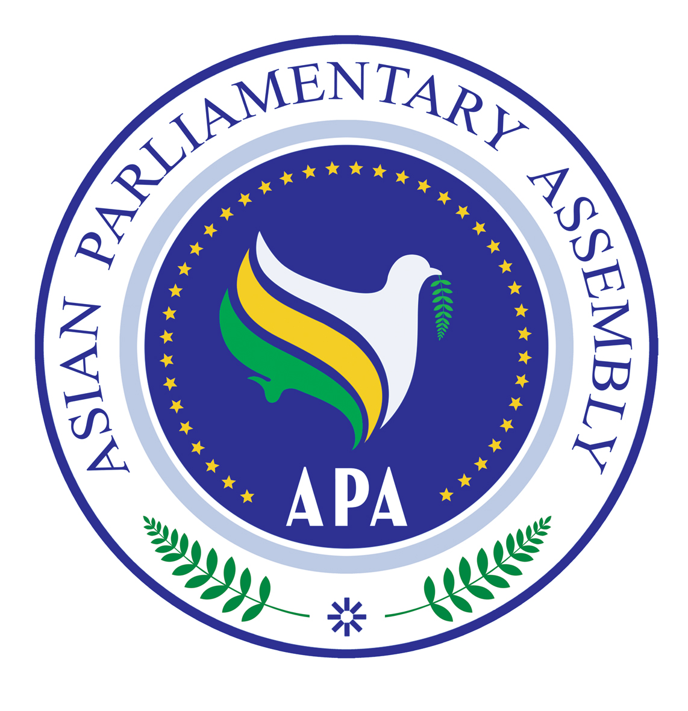
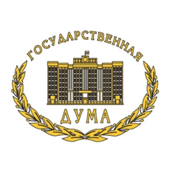

Asian Parliamentary Assembly
Standing Committee on Economic
and Sustainable Development

Naryan-Mar, Russian Federation
April 18-21, 2019

Draft Agenda

- – Adoption of the Agenda
- – Election of the Bureau
- - Opening remarks by the Chairperson
- – Report/Remarks of the APA Secretary-General
- - Consideration and Recommendations on the Draft Resolutions:
- Draft Resolution on Asian Integrated Energy Market
- Draft Resolution on Environmental Issues
- Draft Resolution on Financial Affairs: Ensuring Efforts for Economic Growth
- Draft Resolution on Poverty Eradication
- Draft Resolution on Water and Sanitation in Asia for All
- Draft Resolution on The Role of APA Parliaments in Supporting the Implementation of the Sustainable Development Goals
- Draft Resolution on Adopting a Road Map Providing for Measures to Stimulate Green Finance
6- Working Group on Green Funding
7- Working Group on Integrated Asian Energy Market
8- Working Group on Water Crisis
9- Adoption of the Final Report, Closing Session.
10-Any Other Matters

